express mysql database connection

setupMYSQL

setupNodeApp

create a folder to initiate the backend

create a file called “database.js”

e folder eke idan npm init -y. ->to create package.json file



Then enter this in the package.json file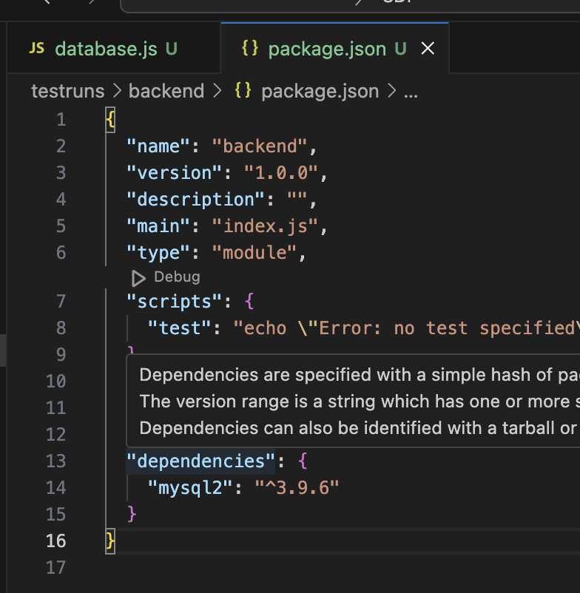



install my sql library -> npm I mysql2

›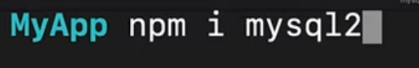

Database file ekata yanne